

**Exercises:   
Sequencing QC**

## Version 2024-11

# Software

The software which will be used in this session is listed below.

* FastQC (<http://www.bioinformatics.babraham.ac.uk/projects/fastqc/>)
* FastQ Screen (<http://www.bioinformatics.babraham.ac.uk/projects/fastq_screen/>)
* MultiQC (<https://multiqc.info/>)

For the exercises today, we will just look at the output reports generated by these programmes.

Example code for running these programmes in a Linux environment is given below:

fastqc path_to_fastq_file.fq.gz

fastq_screen path_to_fastq_file.fq.gz

multiqc path_to_directory_containing_qc_reports

For more details/ options see the specific programme documentations

# Data

The data in this practical comes from:

* Dataset 1: GSE68618
* Dataset 2: GSE176389
* Dataset 3: GSE81795
* Dataset 4: GSE52071
* Dataset 5: GSE135318
* Demo Dataset: GSE115964

*Please note some datasets have been modified for demonstrative purposes

# Background

### Summarising Quality Control in Bioinformatics Processing

All the datasets provided, have been processed using a standard pipeline, the exact details of which vary depending on the library type. While the exact processes involved vary depending on the pipeline/ library type the processing can be broadly summarised as follows:

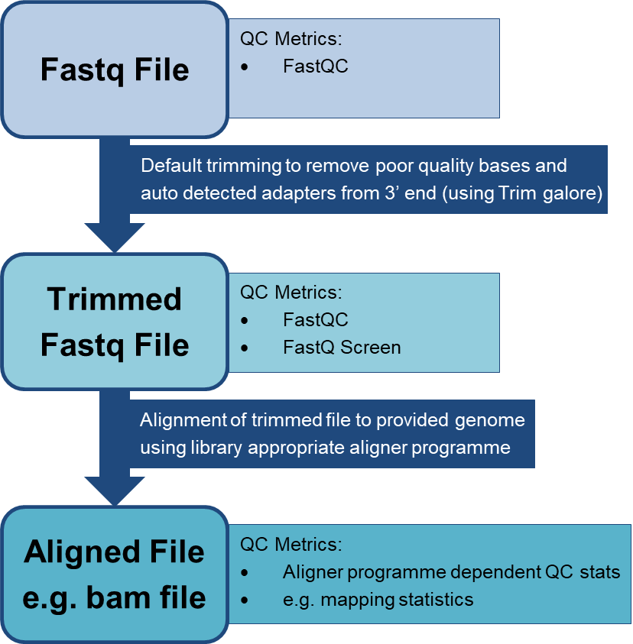



We will look at the individual and collated QC reports from these pipelines to assess data quality in the following exercises.

# Part 1: Assessing Universal Metrics

### Exercise Overview:

* Review FastQC and FastQ Screen Reports for selected datasets
* For FastQC reports you should **focus only on the following sections:**
  + Per base sequence quality
  + Per tile sequence quality*
  + Per sequence quality scores
  + Adapter Content

*Note these datasets are public data and as such do not all have detail on flow-cell tile positions. This means the “per tile sequence quality” section of the FastQC report is not always available. This is the case for Dataset 1.

### Datasets to Review:

Dataset 1

* **Library** **strategy**: WGBS
* **Organism**: mouse

Dataset 2 (optional, if you have time)

* **Library** **strategy**: RNA-Seq
* **Organism**: mouse

Dataset 3 (optional, if you have time)

* **Library** **strategy**: ChIP-Seq
* **Organism**: human

### Files:

* You have been given the QC reports for 1 sample for each data set – these include:
  + A FastQ Screen report (one per sample)
  + A trimmed FastQC report for each fastq file:
    - There will be 1 FastQC reports if the data is Single End
    - There will be 2 FastQC reports if the data is Paired End

### Look at the reports to answer the following questions:

* Can you see any problems with the datasets?
* Which modules do you see an issue in and what does this suggest about the run?
  + e.g. Technical issues with the sequencer, contamination of the library ect.

### Extra points if you have time:

* Do you think there would be a way to improve any of these sequencing datasets?
* What might this involve?
  + e.g. removing poor quality reads by location

# Part 2: Assessing Library Dependent Metrics

### Exercise Overview:

* Review FastQC Reports for selected datasets
* For FastQC reports you should **focus on the following sections:**
  + Per base sequence content
  + Per sequence GC content
  + Sequence Duplication Levels
  + Overrepresented sequences

### Datasets to Review:

Dataset 4

* **Library strategy**: RNA-Seq
* **Organism**: mouse

### Files:

* You have been given the trimmed FastQC report for 2 samples from dataset 4:
  + E14_D0
  + E14_D4

### Question:

One of these samples is normal for an RNA-Seq library, the other is not.   
Which is which?

* Look at the reports – remember to focus this time on modules related to the library type
  + Though feel free to look at the modules we’ve already discussed.
* You can also refer to the data expectations and helpful pointers below, to help get you started.

### Dataset Expectations for an RNA-Seq Library:

* Library is prepared from the transcriptome rather than the genome, therefore we will observe a reduced diversity of sequences relative to genomic analysis
* Library may have been prepared using total RNA or RNA depleted of ribosomal RNA
* Library preparation involves reverse transcription, this introduces a preference in the start site of the reads based on the random priming of the reverse transcriptase

### Pointers:

Below are some questions for you to consider while looking at the reports:

* Thinking about the above expectations what modules do you think could flag as problems in FastQC that are related to the nature of the library?
* Can you spot any issues flagged by FastQC, are they in-keeping with your expectations?
* How similar do the samples look – are there any differences?

# Part 3: Putting it All Together with MultiQC

### Exercise Overview:

* Review MultiQC Reports for selected datasets

### Datasets to Review:

Dataset 5

* **Library** **strategy**: ATAC-Seq
* **Organism**: mouse
* **Biological Replicates**: 2 NPC and 2 mESC

### Files:

* You have been given the MultiQC report which contains a combined summarised view of the different QC reports for each replicate
  + See Background section (p3) for an overview of the QC/ processing pipeline.

### Dataset Expectations

* Key expectations for an ATAC library are:
  + Library preparation involves transposases to target accessible regions of DNA, this introduces a preference in the start site of the reads based on their binding
* Our expectations for mapping are:
  + All samples should map to the mouse genome
* Our need from this data:
  + Typically for ATAC data we are just interested in where our sequences map to in a reference genome – so here individual base calls are less important.

### Look at the MultiQC to answer the following questions:

**General Impressions**

* Can you see the different sections for QC statistics collated from different programmes   
  e.g. Bowtie vs FastQC vs FastQ Screen?
* Can you tell which statistics refer to which sample?
* Can you differentiate statistics from the trimmed and untrimmed fastq files?
  + Hint: trimmed files in this case end “val_1 or val_2

**Reviewing Data-Set Quality**

* Can you identify any issues with the data-set?
  + Is the alignment of the samples as expected?
  + Does the data look as expected for an ATAC library?
* Can you suggest the possible cause of any problems with this dataset?

With all of the above in mind, do you think all (or some) of this library is still usable?

*Part 3: Extended Exercises (If you have time)*

### Additional Exercise Overview:

* Pick one (or more!) of the complete MultiQC reports for the datasets we looked at in Part 1 and Part 2 to review

### Questions to Consider:

* Can you see evidence of the issues we identified in the earlier exercises?
  + If there were problems with only certain samples, can you identify which ones from this view?
  + Are there any cases where you think it would be helpful to refer back the original FastQC or FastQ Screen reports?

### Dataset Details:

If you are unsure of what the different library strategies involve, please check out the “Extended MultiQC Background” section on p8 for a few hints on the libraries involved and some general expectations.

Dataset 1

* **Library** **strategy**: RNA-Seq
* **Organism**: mouse
* **Biological** **Replicates**: 3 Tet1-WT and 3 Tet1-KO

Dataset 2*

* **Library** **strategy**: WGBS
* **Organism**: mouse
* **Biological** Replicates: 1 Old and 1 Young

Dataset 3

* **Library** **strategy**: ChIP-Seq
* **Organism**: drosophila (accidentally mapped to human)
* **Biological Replicates**: 2 H3K4me1 ChIP and 1 input control

Dataset 4

* **Library strategy**: RNA-Seq
* **Organism**: mouse
* **Biological Replicates:** 1 D0 and 1 D4

* Note dataset 2 has been mapped with bismark, this generates:

* Mapping statistics which include detail on the strand alignment
* Additional bismark specific QC metrics
* They are left in so you can check them out, but are beyond the scope of this course

# *Extended MultiQC Background:*

### Important Feature of Different Library Types

In order to address whether there are any QC issues, remember FastQC expects a genomic library however our actual expectations for the dataset will depend on the library type. Below is a quick reminder of some key ways that the libraries we will analyse may differ from a genomic library.

RNA-Seq

* Library is prepared from the transcriptome rather than the genome, therefore will observe a reduced diversity of sequences relative to genomic analysis
* Library may have been prepared using total RNA or RNA depleted of ribosomal RNA
* Library preparation involves reverse transcription, this introduces a preference in the start site of the reads based on the random priming of the reverse transcriptase

ChIP-Seq

* Typically ChIP-seq libraries are randomly fragmented by sonication – sometimes will still see a little bit of bias at the 5’end due to ligation point of adapter
* Library are prepared by fragmented DNA:protein complexes of interested are isolated using antibodies, often these targets are associated with promoters which can have a more enriched GC content than the rest of the genome
* Often fragmented DNA not subject to immunoprecipitation will be included for comparison, termed input controls

ATAC-Seq

* Library preparation involves transposases to target accessible regions of DNA, this introduces a preference in the start site of the reads based on their binding

WGBS

* DNA is subject to bisulfite conversion prior to library generation, in this process unmethylated C’s are converted to T’s

Think about what impact these may have on certain QC metrics

There is also a library-dependent element to assessing the usability of datasets, depending on what we need the data to tell us.

For RNA-Seq, ChIP-Seq and ATAC-Seq:

* Typically just need to know aligned positions to a genome
* So confidence in individual base calls are less important

For WGBS

* Normally interested in the proportion of methylated and unmethylated C’s
* So confidence in individual base calls is more important

Keep this in mind when considering whether a dataset with QC issues might still be usable