

# Exercise:

# Using Inkscape for Figure Design and Editing

Version 2024-05

# Licence

This manual is © 2018-24, Simon Andrews.

This manual is distributed under the creative commons Attribution-Non-Commercial-Share Alike 2.0 licence. This means that you are free:

* to copy, distribute, display, and perform the work
* to make derivative works

Under the following conditions:

* Attribution. You must give the original author credit.
* Non-Commercial. You may not use this work for commercial purposes.
* Share Alike. If you alter, transform, or build upon this work, you may distribute the resulting work only under a licence identical to this one.

Please note that:

* For any reuse or distribution, you must make clear to others the licence terms of this work.
* Any of these conditions can be waived if you get permission from the copyright holder.
* Nothing in this license impairs or restricts the author's moral rights.

Full details of this licence can be found at

<http://creativecommons.org/licenses/by-nc-sa/2.0/uk/legalcode>

# Introduction

In this exercise we are going to give you a set of figures to amend. Once you have modified all of the individual figures you can arrange them together into a suitable figure panel.

## Figure 1 – Red Green Bar Graph (red_green_barplot.svg)

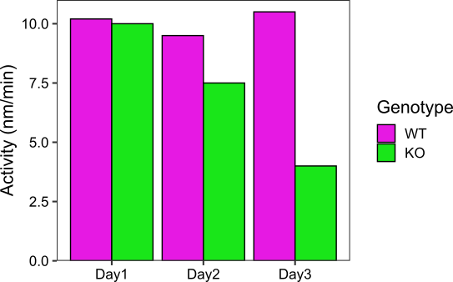For the first figure we have a bar graph drawn in R and exported as an SVG. We want to fix the colours to make them colour blind friendly and tone them down. We will clean extraneous parts of the figure and make the text more readable.

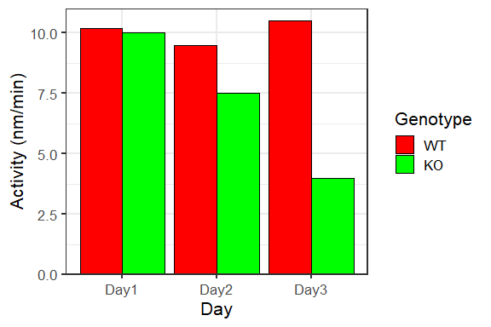

Let’s work through the changes we want to make

### Split the graph into its component parts

When the graph is first loaded it will be a single large object. We need to split it into it’s sub-components so we can edit them.

From the menu pick Edit > Select All, then pick Object > Ungroup. This should split all parts of the graph into separate objects so you can pick them individually.

### Remove background objects and x-axis label

Anything we can do to clean up the graph will make it look nicer. We have a set of grey lines on the background of the main plot which don’t add anything. You can select these individually and press the delete or backspace key to remove them.

You will also find that there are large white boxes behind the whole plot and behind the plot area which aren’t needed and can cause problems when compositing so you can remove these too (you won’t see any obvious difference when they’re gone because the background page is also white).

The x-axis label which says “Day” isn’t needed because the time labels also say this, so remove that too.

### Change from red-green to magenta-green

We only need two colours for this graph so there’s no reason to use a red-green colour scheme. Magenta green is the most friendly scheme for two colours so we’ll use that. The original colours are also 100% saturated which looks quite garish, so we’ll calm those down a bit.

Click and select the first red bar, then hold shift and click on the other red bars and the red box in the legend to select them all. In the menu select Object > Fill and Stroke and then select the Fill tab in the dialog.

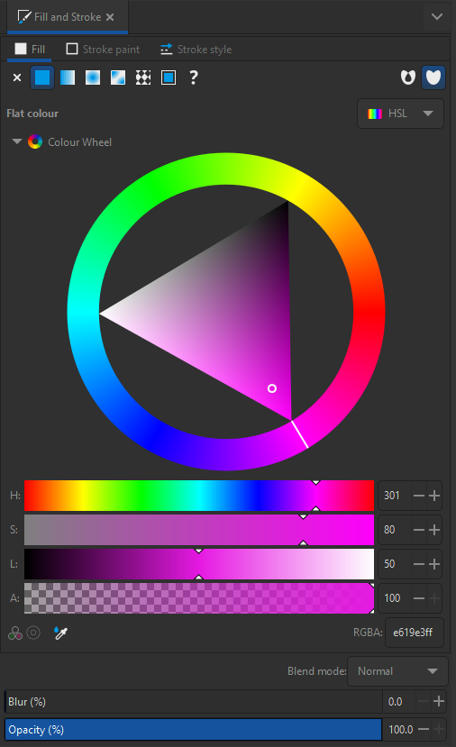

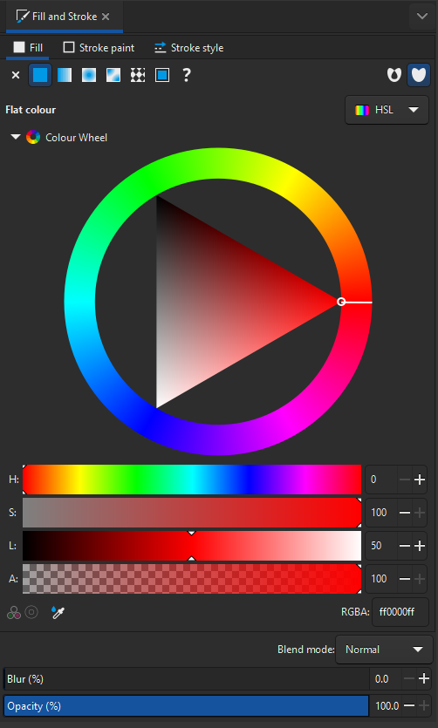Move the outer hue wheel to a magenta shade, and turn the Saturation (S) value down to 80 to get a nicer colour. You should see the colour on the graph change immediately.

After you’ve done this repeat the selection on the green bars / boxes and this time just change the saturation value

### Make the axis labels black

On the original graph the axis labels on both the x and y axes are grey. It would be better if these were black. Select all of the labels on both axes and then in the Fill and Stroke tab change their colour to black.

Save the changes you made to this picture with File > Save and close the file.

## Figure 2 – ChIP-Seq Chromosome View (chromosome_view.svg)

In this figure we’ve taken a screenshot from the SeqMonk genome viewer showing two different ChIP-Seq tracks and we need to improve the presentation of the data.

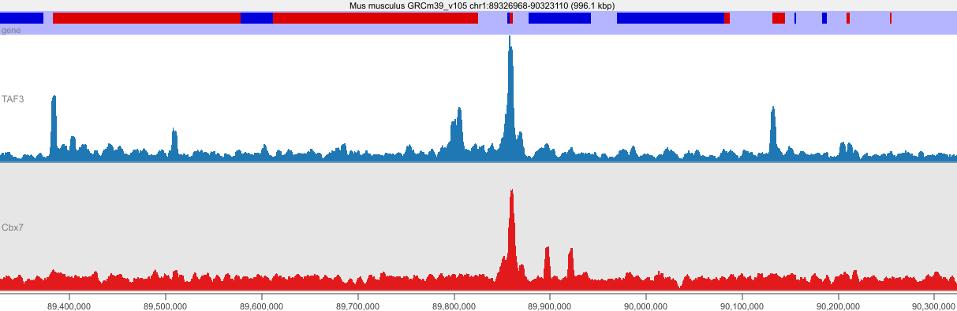

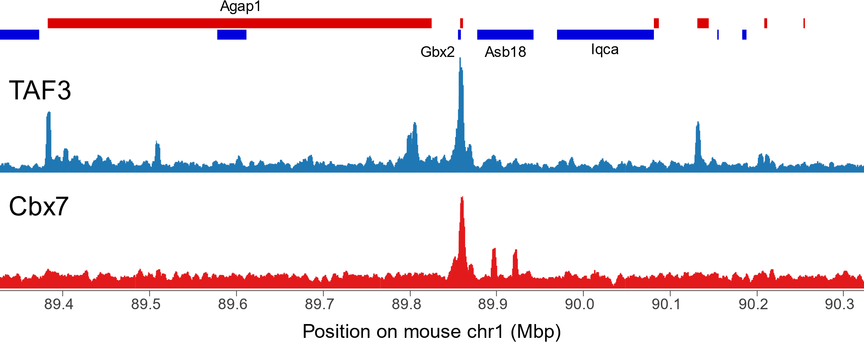

### Split apart and clean up unwanted objects

We again need to start by selecting everything Edit > Select All and splitting it apart Object > Ungroup.

We want to remove the background squares (both grey and white) and the text over the top of the image showing the species and assembly information. We can also remove the blue background from behind the gene track.

### Increase the size of the text

The text on the image is all quite small at the moment so we need to increase it. In some cases what appears to be text is actually a picture of text, so you’d have to replace it, but SeqMonk does actually insert text so we can edit it directly.

We can first make the location text on the x-axis simpler by changing it from bases to megabases, so we can edit it so that 89,400,000 becomes 89.4 which will clean things up. Double clicking on any piece of text should let you edit it.

You can then select all of the text along the bottom and open Text > Text and Font. You can change the font size from 8.5 up to 16 then press Apply. You may need to move the text around a bit to make it line up nicely with the axis again.

You can also increase the size of the labels on the two tracks to make them up to 28pt since they are so important. You can also make these labels black in the same way you did previously. Move the labels a bit if they overlap the data but keep them aligned with each other.

You can remove the small label which says “gene”

If your image is overflowing the background page then that’s fine. You can increase the size of the background by selecting File > Document Properties and increasing the page height.

### Separate Forward and Reverse Strand Genes

In the gene track we have forward strand genes in red and reverse strand genes in blue. Some of these currently overlap which is a bit messy. Select all of the red genes you can see and then use the arrow keys to move these up until they no longer overlap with the blue genes. You will see some smaller red genes emerge which were previously hidden. You can delete these.

### Label Key Genes

We don’t really have enough space to label all of the genes, but adding some names to key genes will help in the interpretation of this data. Use the text tool from the toolbar to add 16pt Arial text names to some key genes.

* The large red gene to the left is Agap1
* The small blue gene over the peak in the middle is Gbx2
* The two blue genes to the right of the main peak are Asb18 and Iqca

Keep the labels you add aligned with each other wherever possible. Try to maintain a sensible alignment with the feature you are labelling (centered or aligned to one end is fine). The alignment tools can be accessed via Object > Align and Distribute

### Add an x-axis label

Finally add a label under the x-axis to say that this is position on mouse chromosome 1 in Mbp. Make sure it’s centered across the page.

Save the modified image

## Figure 3 FISH Microscopy Image (fish.jpg)

Here we have a FISH microscopy image which shows background staining with Alexa and then two other cDNA probes for different genes coloured red and blue

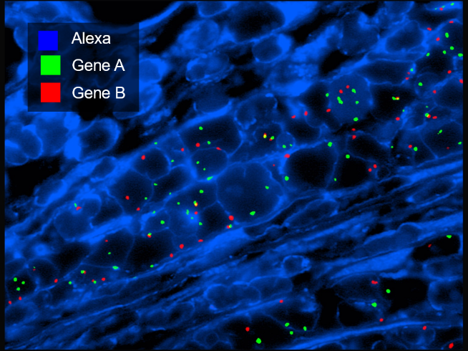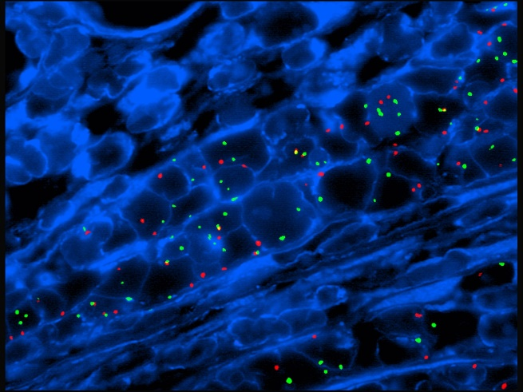

We need to add suitable labels to the plot. First you can open the image in Inkscape using File > Open. You will need to change the file type to search for to “All Images” so that the jpg file shows up. You can accept the default import options.

### Add a contrast box for the labels

Because the image is quite busy we can make it easier to read any text we add by adding a box behind the new labels. To start with add an opaque black box using the box tool in the main toolbar. It doesn’t need to be exactly the right size yet.

### Add the text labels

Write three new, white pieces of text in 40pt Arial font saying

* Alexa
* Gene A
* Gene B

..and place them above each other in the box you created.

They don’t need to be positioned correctly at this point

### Add the coloured blocks

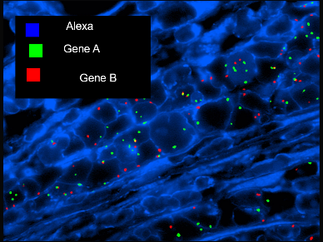Next, we want to add three square blocks containing the red, green and blue colours in the image. We can use the rectangle tool from the toolbar for this. If you hold the control key whilst making the boxes then you can make them be exact squares. Once you’ve made one to around the correct size you can duplicate this using Control + D to make the other two so you know they’re exactly the same size as each other. Fill them with pure blue, green and red and put them next to the labels you made before.

### Sort out the alignment

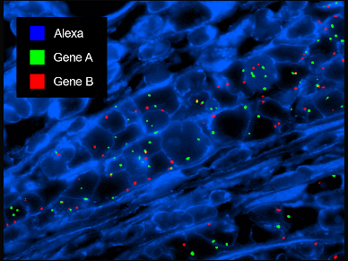Now all of the components are in place you can use the Align and Distribute tool to make everything line up properly.

* The three coloured boxes should be vertically aligned with each other
* The three coloured boxes should be equally vertically spaced
* Each of the labels should be vertically centered with its corresponding coloured box
* The three text labels should be horizontally centered with each others left edges

Once you’ve done this then you can group together the coloured boxes and text. You can then shrink down the background box to an appropriate size and then centre the coloured boxes plus text within it (both horizontally and vertically).

### Add some transparency

At the moment our background box to provide contrast is completely black but we can allow a little transparency so that viewers can see that nothing was being obscured by the box we added. Select the background box and in the Fill and Stroke dialog you can lower the Opacity value. You need to be able to see the text clearly so somewhere around 60-70% opacity should be about right.

### Save the image

Finally, you need to save the image. Although we loaded the image from a jpg we should save as an SVG so the text is saved as a vector and retains its resolution and ability to be edited further.

## Compositing (If you have time)

Take the three modified images you created and assemble them into a figure panel. Open a blank A4 document and import the different images into it. Resize and align them into a sensible structure and label them with A, B and C (doesn’t matter which is which).

Save your composited image and then save it again as a PDF. To ensure maximum compatibility for your PDF convert all text in your image into paths which will work regardless of what fonts are on the machine which views your figures.